**Experiment No.: 1**

**Aim**

Familiarisation of linux commands

**CO1**

Perform system administration task.

**Procedure**

**1:pwd :** print the working directory

**$pwd**

**Output Screenshot**



**2. ls :**View the content of the directory

**$ ls**

**Output Screenshot**



**2.1: ls –R :** All files in subdirectory

**$ls –R**

**Output Screenshot**

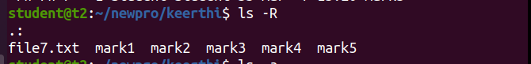

**2.2: ls –l:** long listing

**$ ls -l**

**Output Screenshot**

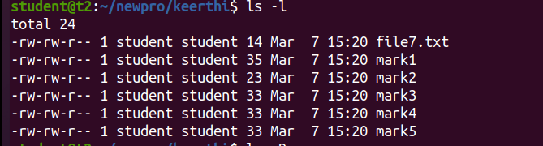

**2.3:** **ls -a :** To list the all hidden files

**$ ls -a**

**Output Screenshot**



**2.4:** **ls -al :** List the files and directory with detailed information

**$ls –al**

**Output Screenshot**

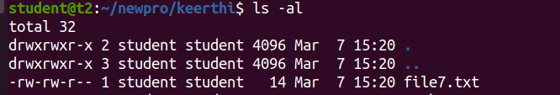

**2.5. ls -t :** List the file sorted in the order of the last modified file.

**$ls –t**

**Output Screenshot**



**2.6.** **ls -r :** To reverse the natural sorting order

**$ ls –r**

**Output Screenshot**



**3. history :** To review the commands that have been previously executed for certain period of time.

**$history**

**Output Screenshot**

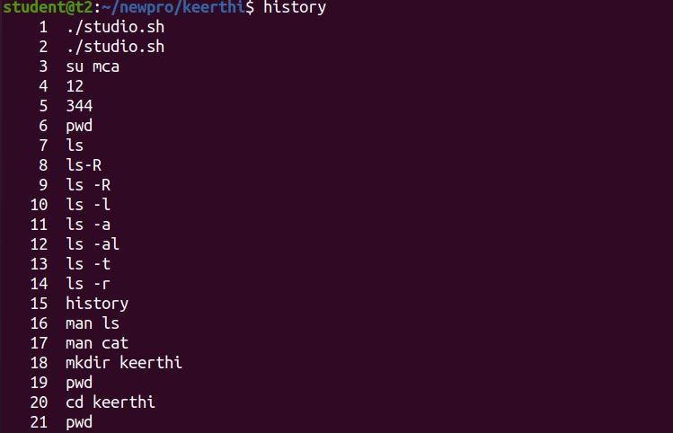

**4. man :** we can learn and understand different commands write from the shell using man command

**$man ls**

**Output Screenshot**



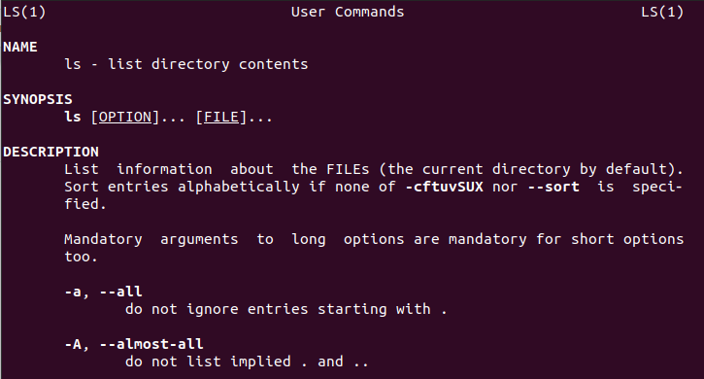

**5. mkdir :** Creates new directory

**$ mkdir newprogram**

**Output Screenshot**





**7. touch :** To create new file

**$touch file.txt**

**Output Screenshot**



**8. cat > [filename]** **:** Create a new file and open it to add content.

**$cat > file .txt**

**Output Screenshot**

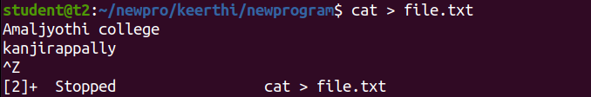

**8.1.cat filename:** To display the file content

**$ cat file.txt**

**Output Screenshot**



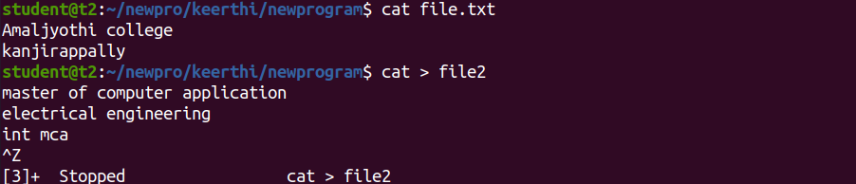

**8.2. cat >> [filename] :** to append new contents to existing file contents

**$cat file.txt file2 >file3**

**$ cat file3**

**Output Screenshot**

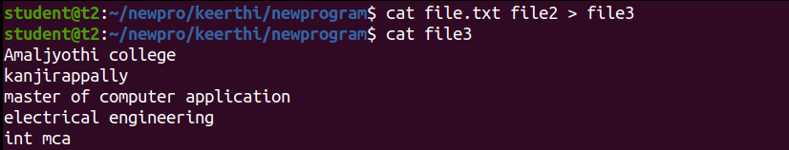

**8.3. cat -n [filename] :** To display content with line numbers

**$cat -n file3**

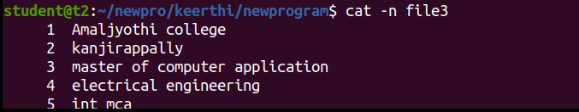

**8.4. cat -e [filename] :** To display $ character at the end of each line.

**$cat -e file3**

**Output Screenshot**

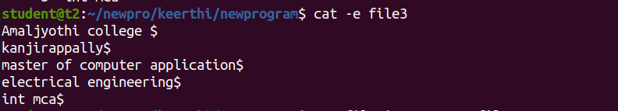

**Result**

The program was executed and the result was successfully obtained. Thus CO1 was obtained.

**Experiment No.: 2**

**Aim**

Familiarisation of linux commands

**CO1**

Perform system administration task.

**Procedure**

**1:cd [directoryname]:** Change in directory

**$cd keerthi**

**Output Screenshot**



**2: . cat > [filename]** **:** Create a new file and open it to add content.

**$cat > file7 .txt**

**Output Screenshot**

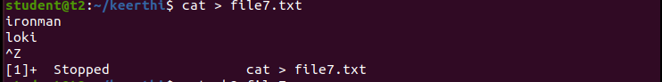

**3:** **cut –b1 [filename] :** It is used to cut a specific section by bytes.

**$cut –b1 file7.txt**

**Output Screenshot**



**3.1:** **cut –c2 [filename] :** It is used to select the specified characters.

**$ cut –c2 file7.txt**

**Output Screenshot**



**3.2: . cat > [filename]** **:** Create a new file and open it to add content.

**$cat > mark3**

**Output Screenshot**

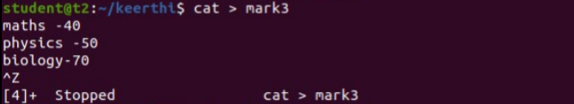

**3.3.cut –d - -f1 mark1 :**  It is used to cut a specific section by a delimiter.

**$ cut –d - -f1 mark1**

**Output Screenshot**

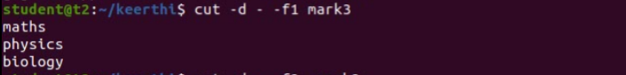

**3.4. cut –d - -f2 [filename] :** It is used to select the specific fields. It also prints any line that does not contain any delimiter character, unless the -s option is specified.

**$ cut –d - -f2 mark3**

**Output Screenshot**

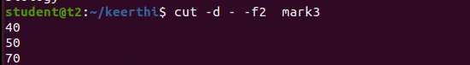

**3.5. cut –d ‘ ’ -f2 [filename] :** It is used to select the specific fields. It also prints any line that does not contain any delimiter character, unless the -s option is specified

.

**$ cut –d ‘ ’ -f2 mark3**

**Output Screenshot**

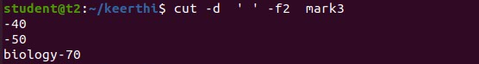

**4.** **paste [filename]**

**$ paste mark3 mark4**

**Output Screenshot**

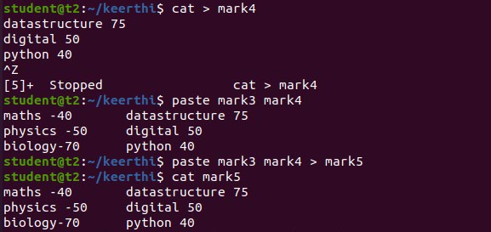

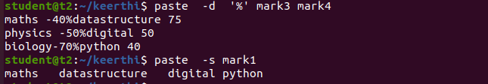

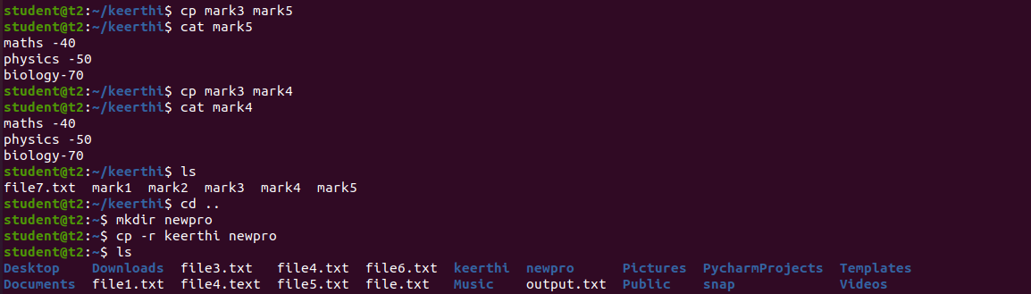

**Result**

The program was executed and the result was successfully obtained. Thus CO1 was obtained.